**Where can I access baseline data for my students?**

SPA is the primary location to identify baseline data for your students.



The ‘My Students/NYS Assessment’ Dashboard contains results for

* NYS Assessments: ELA, Math, Science, Regents/RCT, NYSESLAT, NYSAA

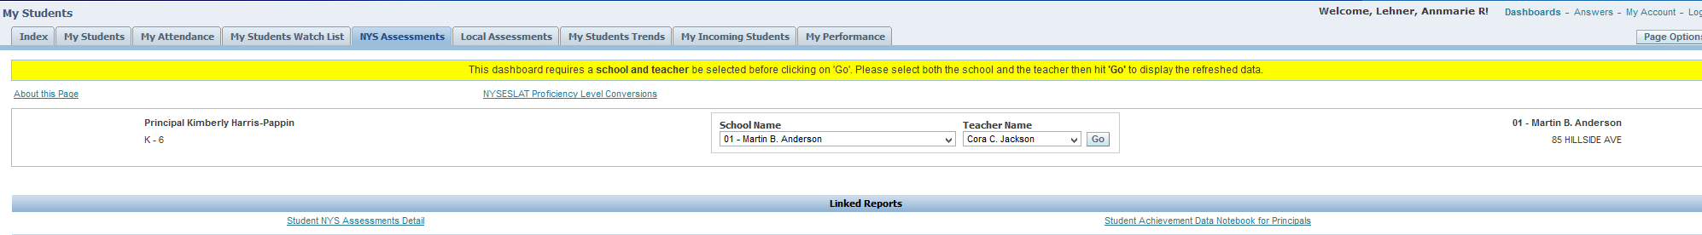

In addition, links to ‘Student Achievement Data Notebook for Principals’ SharePoint sites have been added to this dashboard. These Data Notebooks contain NYS Item Level Analysis Reports for your students. Please click on this link to the Data Notebook SharePoint site, and click on the link to your school.



The ‘My Students/Local Assessments’ Dashboard contains results for

* Aimsweb, NWEA Assessments, SLO related Post Assessments



The ‘My Students/My Student Watch List’ Dashboard is also a tool that can provide you with detailed information about your students’ progress, and can serve as predictors towards students who may be at risk.